CSC220 · WEB DEVELOPMENT II
Assignment 1 @ Week 3
Build a Commit History
Project | Use your Week 2 API mini-app.
Total | 25 points
Evidence | Complete every task and insert a screenshot in the placeholder provided after each task.
Student Information
Name: __________________________________ | Student ID: __________________________________
Section: __________________________________ | Date: __________________________________
Instructions
- Complete the tasks in order using the VS Code integrated terminal.
- Use your real name and university email when configuring Git.
- Use clear, meaningful commit messages for each logical change.
- After completing each task, paste a screenshot into the provided evidence box.

Task 1: Configure Git
Configure Git using your real name and your university email.
Use your real name:
$ git config --global user.name "Your Name"

Use your university email:
$ git config --global user.email "your@email.com"

Screenshot Evidence
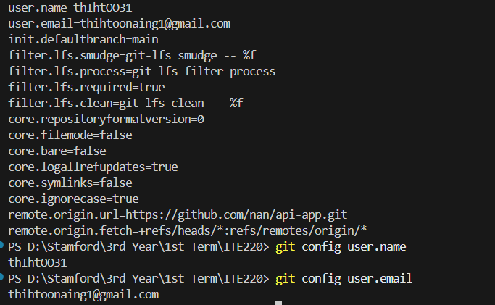

Task 2: Create .gitignore
Create a file named .gitignore in your project.
It must contain at least:
node_modules/
.env

Screenshot Evidence
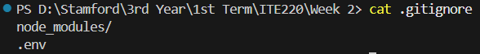

Task 3: Initialize the Repository
Initialize Git in your Week 2 API mini-app project folder.
$ git init

Then create your first commit. For example:
$ git add .
$ git commit -m "Initial commit"

Screenshot Evidence

Task 4: Make at Least Three More Commits
Make changes to your project and commit each logical change separately.
For example:
Initial commit
Add .gitignore
Handle fetch errors
Add loading state

You should have at least four commits in total:
- 1 initial commit
- 3 additional commits
Screenshot Evidence
Insert Screenshot for Task 4 Here
Paste your screenshot inside this box.

Task 5: Show Proof
Run the following command to display your commit history:
$ git log --oneline

Example output:
8e1f0aa Add loading state
5d4c3b2 Handle fetch errors
2a1b0c9 Add .gitignore
7f6e5d4 Initial commit

Then check the configured username:
$ git config user.name

Take screenshots showing this information and paste them below.
Screenshot Evidence
Insert Screenshot(s) for Task 5 Here
Paste your screenshot inside this box.
Final Check
- Git is configured with your real name and university email.
- .gitignore contains node_modules/ and .env.
- The repository has an initial commit.
- The repository has at least 3 additional meaningful commits.
- git log --oneline and git config user.name proof is included.

